Template Final Exam

|  |  |  |
| --- | --- | --- |
| # | Full Name | Group |
|  | Amanzhan Aida | CS-2124 |
|  | Sarsenova Akkumis | CS-2121 |
|  |  |  |
|  |  |  |

|  |
| --- |
| Link to the repository:  [Ssandstormm/Final-project-OSC-Akkumis-and-Aida (github.com)](https://github.com/Ssandstormm/Final-project-OSC-Akkumis-and-Aida) |

Step-by-step task completion:

**Task 1:**

**Adding a New User to the System**

1 step: Log in as Root: To log in as root, we open a terminal window and enter the following command:



2 step:Add a New User: To add a new user,we use the **useradd** command. In this case, we are adding a user named "student". The command is as follows: 

3step : Set a Password for the New User: To set a password for the new user, we use the **passwd** command. The command is as follows: 

 Then re-type the password again and we got this command , which means that we successfully added the student user.

4 step:Then we entered the **whoami** command and we made sure that you were logged in as

5 step: a **student** user. To shut down the user, we used the **exit**  command. Because our VM does not support this command.

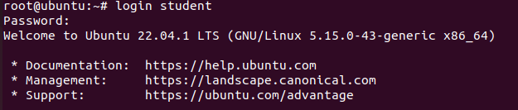

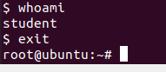

This will close the current user session and return you to the login prompt.With these steps, we have successfully added a new user to the system, logged in as the user, verified the user, and logged out of the user session.

**Task 2:**

**On virtual machines, implement all three methods of connecting to the Internet (a "Direct" IP connection to the Internet, a connection via NAT and a connection via a proxy server).**

1. **"Direct" IP connection to the Internet**

To directly connect to the Internet in Linux, we will need to configure our network settings. Here is a step-by-step explanation for connecting to the Internet using a direct IP connection in Linux:

**1.Identify network interface.**

We use the command **ip addr show** to list all of your network interfaces and their status.

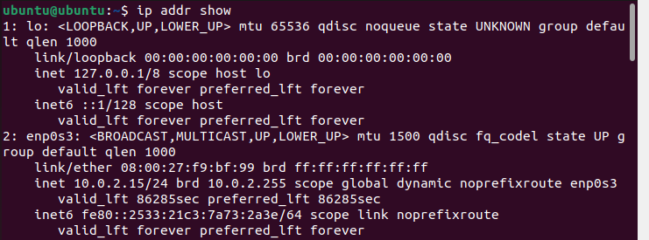

2.Configure the IP address: we used the command **sudo ip addr add 10.0.2.15/24 dev enp0s3** to configure the IP address for the network interface connected to the Internet.



3.Configure the default gateway: we used the command **sudo ip route add default via 10.0.2.0** to set the default gateway for your network interface.



4.Configure the DNS server: we used the command **sudo echo "nameserver 1270.0.53" >> /etc/resolv.conf** to configure the DNS server for your network interface.



5.Test our connection: we use the command ping 127.0.0.53

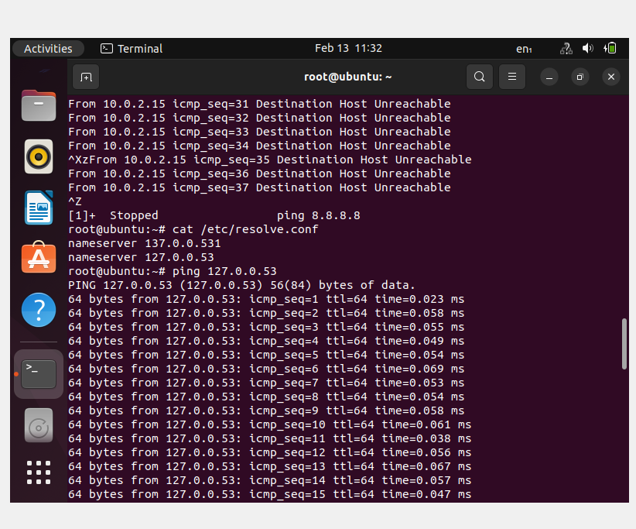

**We connect successfully!**

1. **Proxy server**

**Firstly we install curl command and check our connection**

1. 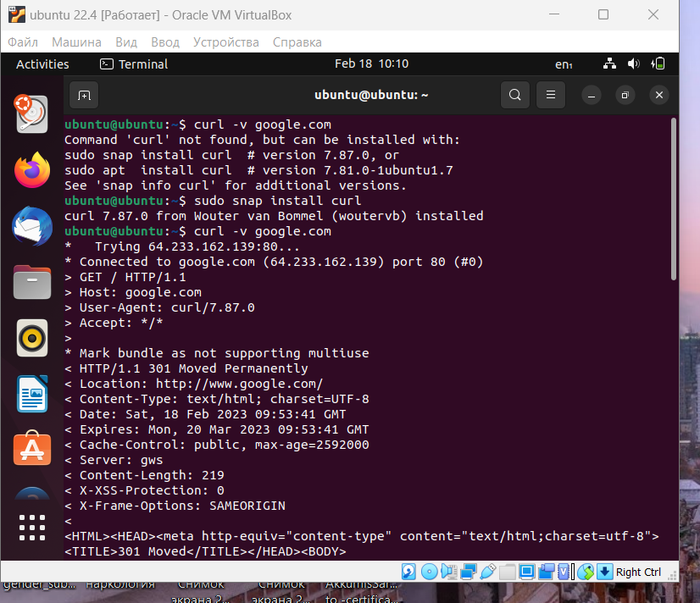

**then we ping google.com**

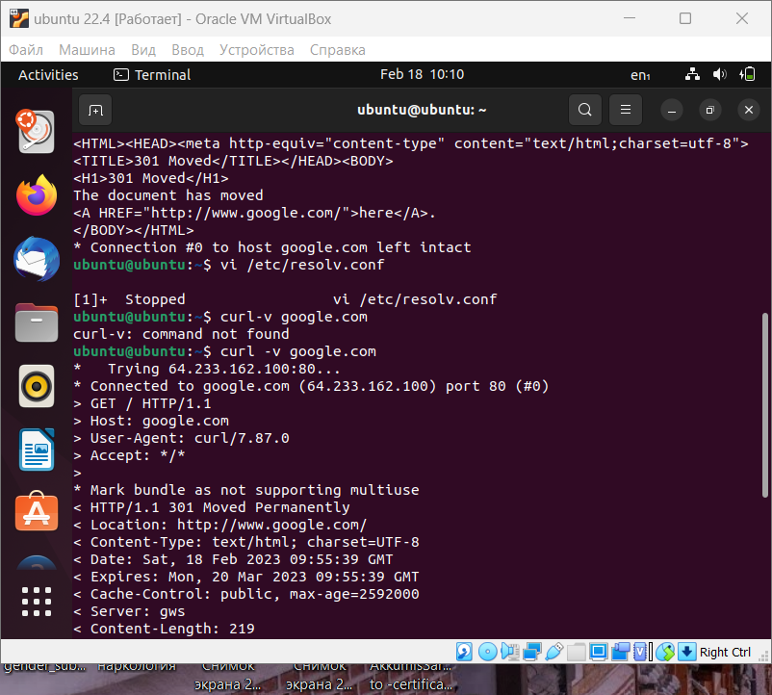

**b)** **connection via NAT**

**first we use iptables to access certain resources on the host's LAN.**

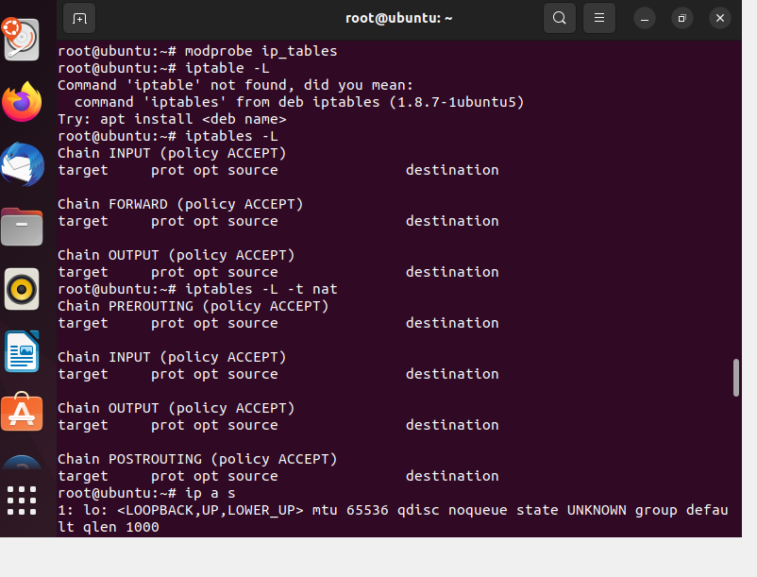

After that, we create configuration files and write the following commands

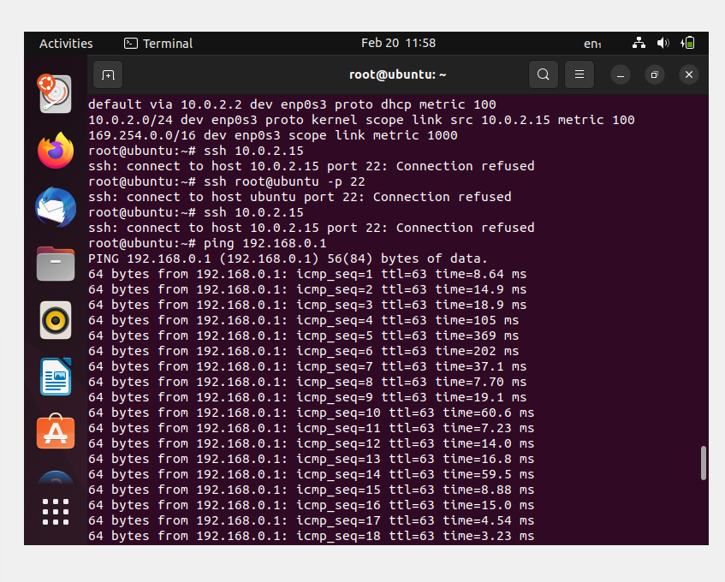

as you can see now we have MASQUERADE

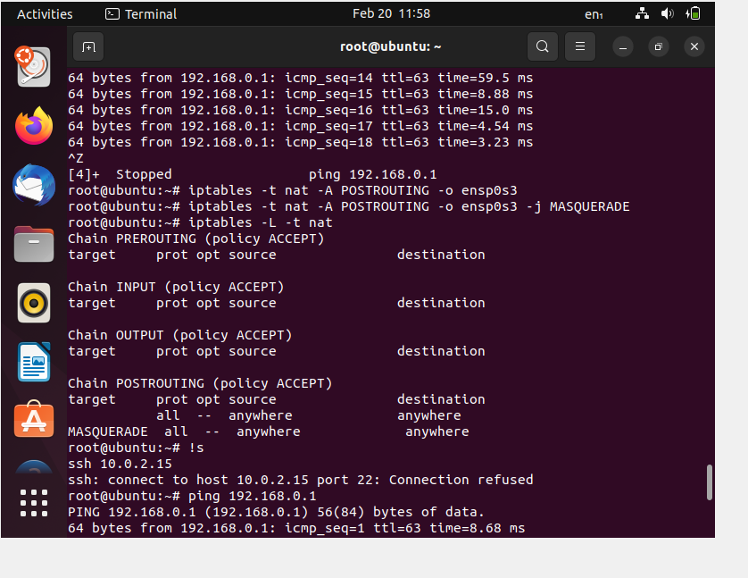

**Task 3:**

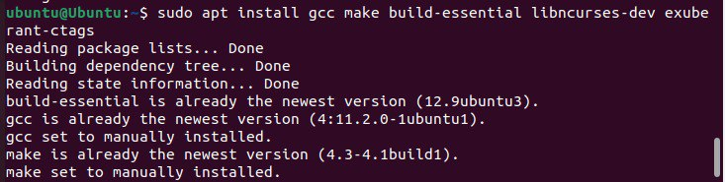

Before starting we need to download the needed libraries.

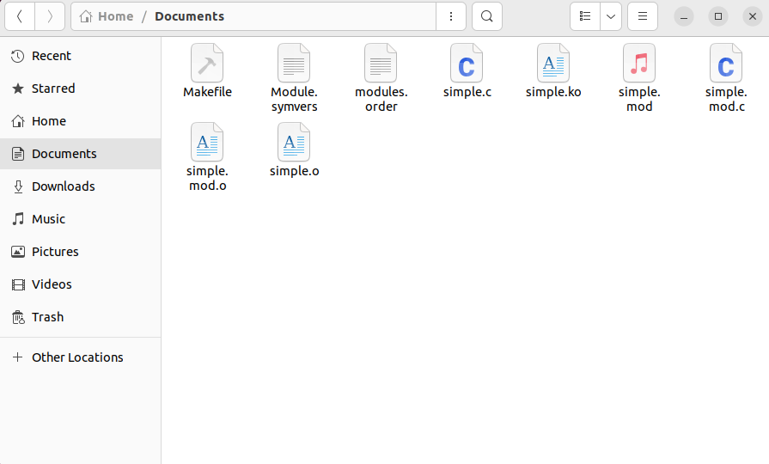

To create a driver, we wrote code in C. To run this code we made a makefile. (Other files were automatically created after running our driver)

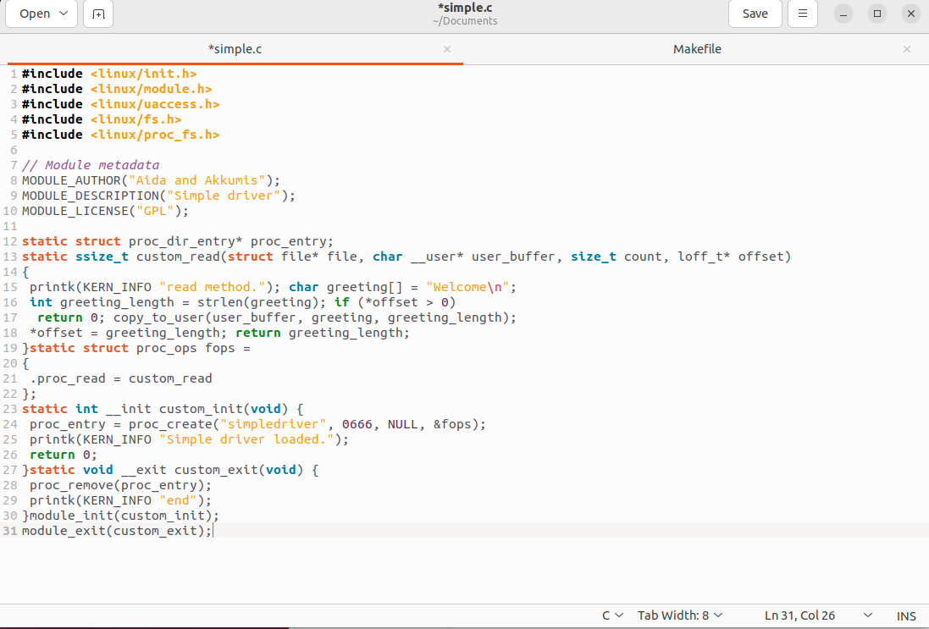

This C program will show us all processes. After running, was created an application with the name “simpledriver”.

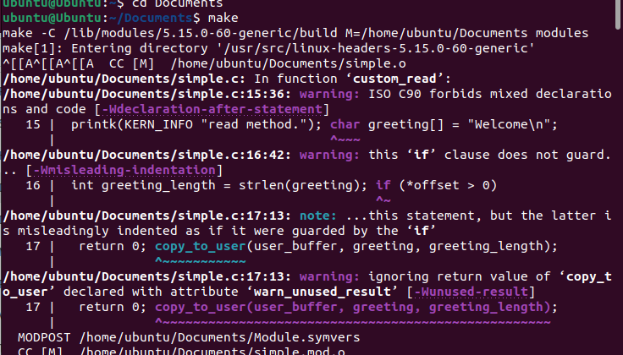

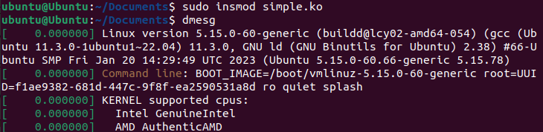

Here we can see that application was created. And special messages appeared.



And with this command, we can read what is inside this app.

Also with this command, we can delete our mini app.

**This driver can show processes and create application with text. After we can check the existence of this app via special command.**